Name: ______________________ Class: ______ Time: 30 minutes Total Mark:____/36
Year 7

Mini Test 4

Show working and answers on this sheet. Show working in sufficient detail to support your answers. Incorrect answers without supporting reasoning may be allocated zero marks.

No Resources Allowed

Question 1 2 marks

How many cubic centimetres are there in the following rectangular prisms? (Each cube represents 1cm³).

- b)
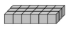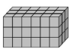


Question 2 4 marks

What is the volume of the following shapes?

- b) c)
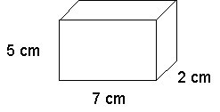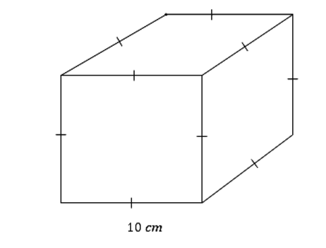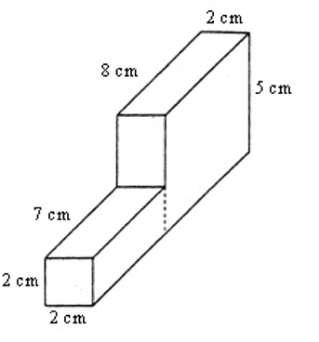

Question 3 3 marks

Convert the following: (Hint: 1000cm³ = 1000mL).

- 4,000cm³ to mL ___________________________

- 27,000cm³ to L ___________________________

- 3cm³ to m³ ___________________________

Question 4 3 marks

A toy box is filled with wooden cubes that are 2cm long, 2cm wide and 2cm high. How many cubes would be able to fit in the toy box if the dimensions are 40cm wide, 60 cm long and 20cm high?

Question 5 3 marks

A rectangular prism has a volume of 360cm³. It is twice as high as it is long and it has a width of 5cm. Find its height.

Question 6 2 marks

Order the following from lowest to highest:

-2, 1, -6, 7, 0 ____________________________________

Question 7 3 marks

Place either a < or > in between each set of numbers:

- -1 ___ 1

- 0 ___ -2

- -17 ___ -3

Question 8 5 marks

- Complete the following:

  - 4 + -5 = __________

  - 14 + 19 = __________

  - -3 + -2 = __________

  - -7 - 6 = _________

  - -4 - -8 = __________

Question 9 6 marks

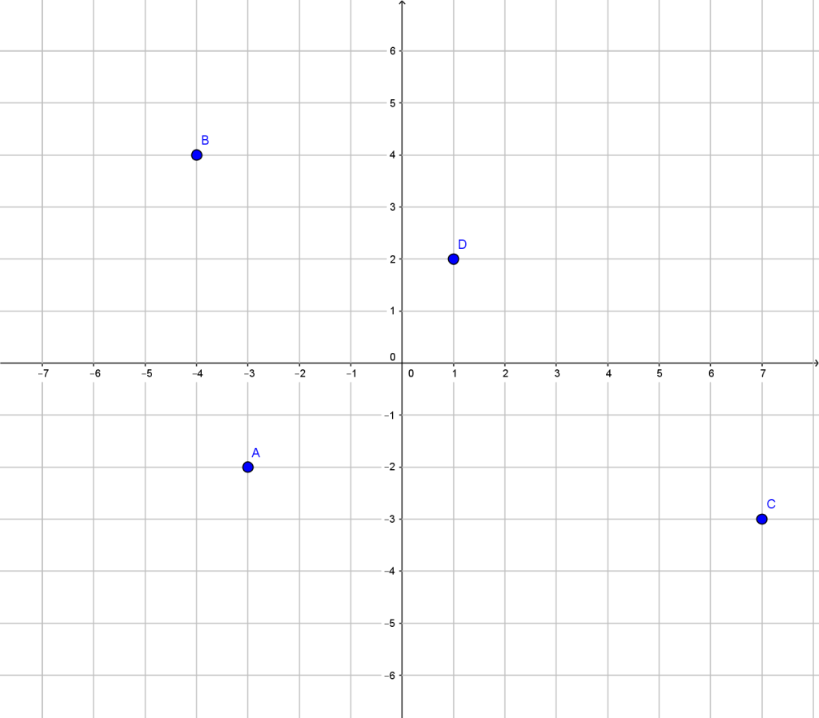

Look at this graph.

- Write the coordinates for A, B, C & D.

A ______ C ______

B ______ D ______

- Plot the following coordinates on the graph above.

E (6, 1) F (0, 5) G (-1, -4) H (-7, 0)

Question 10 5 marks

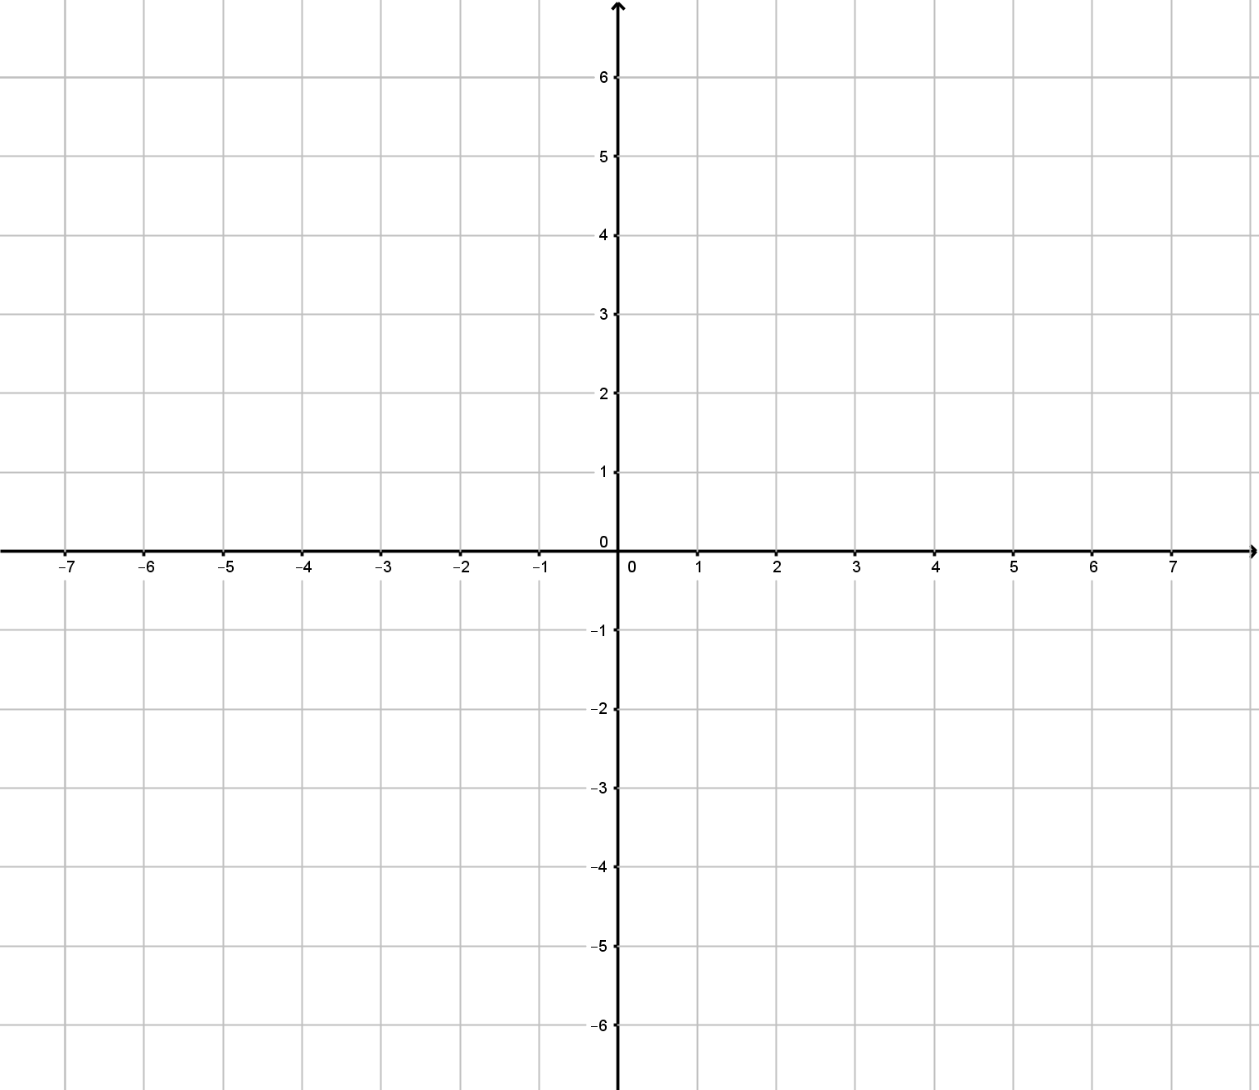

Using the graph above:

- Plot the following points.

(-1, 0), (-2, -2), (2, 6), (0, 2), (1, 4)

- Determine whether the pattern is linear. Justify your answer.

END OF TEST

